ELEMENT 5 - NATURAL, AGRICULTURAL, AND CULTURAL RESOURCES

Introduction
This element includes an inventory and analysis of the natural, agricultural, and cultural resources in the Town of Sherman. Within the following narrative, various components of the community resource base are examined at a broad level or “planning scale.” The purpose of this examination is to provide the community with the necessary information to make informed decisions about future growth and development.

  - NATURAL RESOURCES

The protection of sensitive natural resources is necessary for the welfare of people and the environment. By allowing natural processes, such as the hydrologic cycle/system, to function without impediment, property, water supply and environment are protected. The protection of natural resources also preserves important ecological communities. Certain natural resources have more than merely aesthetic and recreational activity values. They are essential to long-term human- survival and the preservation of life, health and general welfare. As such, the protection and/or management of these natural resources are clearly in the public interest. Thus, the analysis of those natural resources found within the study area is done for the purpose of directing development away- from specific areas not intrinsically suitable for a particular use and given the physical characteristics found within the study area, to guide development in a direction that is least disruptive.

Location
The Town of Sherman is located within the northern highland geographic province, a pitted outwash plain of heavily forested terrain with many lakes, potholes, and wetlands. The topographic features of the Town are resultant from the last glacial age that occurred about 15,000 years ago. The Town lies within the highland lake district of northern Wisconsin, an area with some of the highest lake densities in the world. The Town lies within six watersheds with most lands draining to the Bear River and the Turtle-Flambeau Flowage.

The lakes region of southern Iron County has seen an increase in the development of recreational homes, cottages, and cabins. Development pressure within the Town of Sherman is presently concentrated around the lake areas. Many lakes and rivers in the town are located on public lands. The Turtle-Flambeau Scenic Waters Area contains several thousand state-owned acres of water and miles of undeveloped shoreline.

Topography & Slope
Topography is considered level to rolling, with -elevation ranging from 1,512 feet above sea level at the Flambeau River in Section 7, T41N-R2E to 1,706 feet, near Sister Lakes in Section 7, T41N-R3E. Steep slopes are sensitive areas due to the potential for soil erosion, slope instability and increased runoff velocity. As a rule, slopes more than 15-20 percent are considered ‘steep’. Development in these areas often requires costly engineering and site preparation/mitigation measures to minimize potential adverse impacts. Development in these areas should be avoided, and a natural state maintained. Slope evaluation should be used in conjunction with the examination of other physical factors such as geology, soils, and local drainage patterns). Elevation, Topography, & Steep Slopes in the Town of Sherman are depicted in Map 5.1.

Ecological Landscapes and Land Types
Ecological Landscapes are broad ranging areas with similar ecological potential and geography. The Town of Sherman is located primarily within the Northern Highlands Ecological Landscape (EL). This landscape is characterized by pitted outwash plains, kettle lakes, large peatlands and extensive forests. The North Central Forest EL encompasses the areas west of the Turtle- Flambeau Flowage. This landscape is a heavily forested region with numerous small drainages and lakes that characterizes much of northern Wisconsin.

Ecological Landscapes are comprised of many individual Land Type Associations (LTA’s). LTAs are classified and mapped based on the associations of biotic and environmental factors that include climate, physiography, water, soils, air, hydrology, and potential natural communities. Land Type Associations can be interpreted to provide land information useful for planning and development. Iron County EL’s and LTAs are depicted in Map 5.2.

Ecological Landscape → Land type Association

LTAs of the North Central Forest Ecological Landscape in the Town of Sherman

Chequamegon Washed Till and Outwash (212Xa03)
This LTA encompasses part of the southwestern corner of the Town, west of the Turtle-Flambeau Flowage. The characteristic landform pattern is rolling collapsed moraine and outwash plain complex. Soils are well drained and moderately well drained loamy and sandy soils with a sandy loam surface over non-calcareous loamy sand till, along with very poorly drained nonacid organic soils. Soil Associations include the Padus-Keweenaw-Sarwet-Pence-Lupton, Worcester-Manitowish-Vilas-Croswell, Rosholt-Cress-Antigo Associations.

Northern Highland Outwash Plains (212Xb01)
This LTA encompasses most of southeastern Iron County, and a substantial portion of the lakes region of Vilas, Oneida, and Lincoln Counties. The characteristic landform pattern within this LTA is undulating pitted and unpitted outwash plain with swamps, bogs, and lakes common. Soils characteristics include well-drained, moderately well drained, and poorly drained loamy and sandy soils with a sandy loam surface over non-calcareous gravelly sand outwash, along with very poorly drained acid and nonacid organic soils. Soil associations include Padus-Pence-Loxley-Seelyeville-Manitowish-Worcester, Vilas-Rubicon-Croswell associations.

Vilas-Oneida Sandy Hills (212Xb02)
The characteristic landform pattern is rolling collapsed outwash plain with bogs common. Soils are excessively drained and well drained sandy soils with a loamy sand, sand, or sandy loam surface over non-calcareous gravelly sand or sand outwash or loamy sand till, along with very poorly drained acid organic soils. Soil associations include Sayner-Karlin-Rubicon-Loxley- Keweenaw-Pence Associations.

Vilas-Oneida Outwash Plains (212Xb03)
The characteristic landform pattern is level pitted and unpitted outwash plain with bogs and lakes common. Soils are excessively drained, poorly drained, and moderately well drained sandy soils with a sand surface over non-calcareous sand outwash, along with very poorly drained acid organic soils. Soil associations include the Rubicon-AuGres- Croswell-Loxley, Padus-Pence Associations.

Powell Marsh (212Xb04)
LTA occurs on the far eastern edge of the Town of Sherman, extending eastward into Vilas County. The characteristic landform pattern is level bog with common small sandy islands. Soils are very poorly drained acid muck with a peat surface over muck or sand outwash. Soil associations include Loxley-Dawson, Croswell-Rubicon-AuGres Associations.

Soil Characteristics
An understanding of local soils is an important part of land use planning. Soil factors such as wetness, drainage capacity, strength, and depth to bedrock all influence soil suitability for land uses. The soils of the Town of Sherman are derived primarily from the weathering of glacial deposits. Local soils can be characterized as medium coarse textured soils with high-medium permeability.

Soil associations in Iron County have been mapped by the Natural Resources Conservation Service (NRCS). Soil associations are landscapes that have a distinctive proportional pattern of soils. They provide a generalization of soils found within a large geographic area and are not suitable for site-specific analysis. Town of Sherman Generalized Soils are depicted in Map 5.3.

Table 5.1: Soil Associations in the Town of Sherman

General Soil Association Unit | Soil Type & Representative Slope
Loxley-Kinross-Croswell-Au Gres (s8708) | Mucky peat; 0-2% representative slope
Monico-Goodwit-Champion (s8707) | Silt loam; 0-5%; representative slope
Pence-Champion (S8703) | Silt loam; 0-5%; representative slope
Pence-Padus (s8705) | Fine sandy loam; 15-45% representative slope
Rifle-Lupton-Loxley-Cathro (s8702) | Muck; 0-5%; representative slope
Rock Outcrop-Michigamme-Gogebic (s8709) | Very stony; 6-35% representative slope
Sayner-Rubican-Omega (s8704) | Loamy sand; 5-15% representative slope
Udorthents-Selkirk-Hibbing (s8716) | Clay loam; 0-7% representative slope
Watton-Alstad Variant (s3425) | Silt loam; 1-8% representative slope
Witbeck-Sarona-Gogebic (s3377) | Very stony, muck; 0-2% representative slope
Source: USDA-NRCS

Geology
Subsurface geologic conditions can strongly influence future development potential. Improper land use can result in contaminated water supplies, septic tank failures, and damaged roads. Undifferentiated crystalline rocks underlie the Town of Sherman. Glacial deposits cover bedrock at depths of 50 to 100 feet. Outwash covers most of the southern portion of Iron County.

Geologic Units found in the Town of Sherman
- Biotite schist
- Mafic metavolcanic
- Post-tectonic granitic rocks

Legacy Places
Legacy Places are Wisconsin’s most critical areas in meeting the State’s conservation and recreation needs for the next 50 years. The Wisconsin Department of Natural Resources defined 228 legacy places statewide in the 2002 report “Wisconsin Land Legacy Report: An Inventory of Places Critical in Meeting Wisconsin’s Future Conservation and Recreation Needs. Within the Town of Sherman, the WDNR has identified the Turtle-Flambeau Flowage as a Legacy Place.

The Turtle-Flambeau Flowage is a 13,545-acre reservoir with 211 miles of wilderness shoreline. The Flowage is a popular recreation destination for those seeking fishing and wilderness camping experiences. The environmental and recreational values associated with the Flowage are primary reasons this resource is classified as a Legacy Place. The Flowage:
- is one of northern Wisconsin’s most popular backcountry areas
- is surrounded by an abundance of public land
- provides habitat for numerous wildlife species
- provides old-growth hemlock and pine habitats in surrounding woodlands
- provides many recreational opportunities (boating, fishing, camping) to the public

The protection of legacy places is critical from both a local and statewide perspective. The ties between demand for recreational opportunities and the quality of the natural environment are strong. Local economies in Iron County are strongly dependent upon these resources to provide the recreational opportunities needed to generate revenue within the community. Local policy, planning, and the development of appropriate strategies for the future will ensure that these resources remain viable for future generations.

Existing Land Cover
Land cover information was obtained through analysis of the WISCLAND2 based on 2010-2014 Landsat satellite imagery. This information can be used to develop a generalized local land cover profile and to quantify the relative proportion of individual vegetation cover types on the landscape.

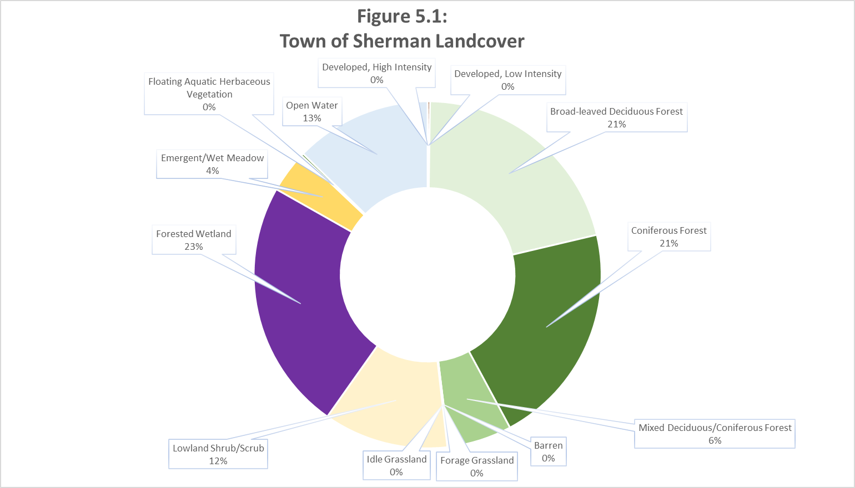

The dominant land cover types are forest and wetlands, which comprise 80 percent of the total land area in the Town of Sherman. The primary upland forest species are aspen (Populus spp.), sugar maple (Acer saccharum.), and red and white pine (Pinus resinosa and strobus). The forest community in the Town of Sherman includes many other coniferous and deciduous species occurring at varying local densities throughout the Town.

Woodland cover plays a key role in the function and value of sensitive environmental areas like steep slopes, wetlands, and floodplains. Regulation of the removal of woodland vegetation is necessary to protect scenic beauty, control erosion, and reduce effluent and nutrient flows into surface water bodies\courses. Forest products and processing are vital components of the Iron County economy.

Table 5.2: Forest Cover
(Including forested wetlands)
Cover Type | Acres | Percent of Town
Aspen/Paper Birch | 8,015 | 9.3%
Jack Pine | 833 | 0.9%
Mixed Deciduous/Coniferous | 5,107 | 5.9%
Red Pine | 2,412 | 2.8%
Sugar Maple | 8,686 | 10.0%
Forested Wetland: Broad-leaved Deciduous | 4,796 | 5.5%
Forested Wetland: Coniferous | 15,277 | 17.7%
Forested Wetland: Mixed Deciduous/Coniferous | 176 | 2.0%
Source: WISCLAND2

Wetland communities in the Town of Sherman consist of three dominant types, emergent/wet meadow, scrub/shrub, and forested wetlands. Dominant plant species found in local open bog land communities include tamarack (Larix laricina), black spruce (Picea mariana), leatherleaf (Chamaedaphne calyculata), and tussock cottongrass (Eriophorum vaginatum), and sphagnum moss. Other wetland plant species associated with local wetlands include small cranberry (Vaccinium oxycoccos), bog rosemary (Andromeda glaucophylla), bog laurel (Kalmia polifolia), bog sedge (Carex oligosperma), tawny cottongrass (Eriophorum virginicum), sphagnum mosses (Sphagnum spp.), and wool grass (Scirpus cyperinus). Wetland species associated with the coniferous swamps of the region commonly include northern white cedar (Thuja occidentalis), yellow birch (Betula alleghaniensis), black ash (Fraxinus nigra), speckled alder (Alnus incana ssp. rugosa), along with many sedges and flowers. The deciduous wooded swamps of the region are commonly associated with black ash (Fraxinus nigra), lake sedge (Carex lacustris), ostrich fern (Matteuccia struthiopteris), and marsh marigold (Caltha palustris). Many other species ferns, grasses, sedges, and flowers also inhabit these environments.

Small, scattered pockets of grassland, barren land, and shrub land are also found throughout the Town. These land cover types account for less than five percent of the vegetative cover in the Town of Sherman.
Town of Sherman land cover is depicted in Map 5.4.
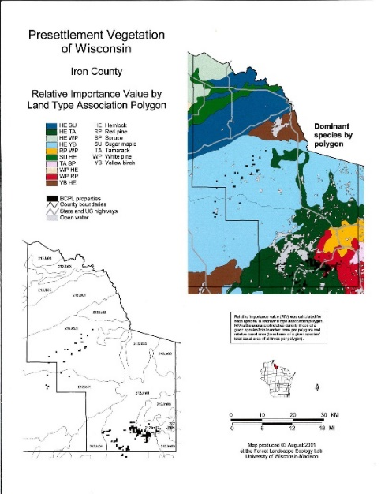

Historic Land Cover
Historic land cover was derived from “Finley’s Pre-settlement Vegetation” GIS coverage for Wisconsin. The original or pre-settlement vegetative cover in the Town of Sherman consisted of wetland vegetation (swamp conifers) and a deciduous-coniferous mixed forest. Isolated pockets of boreal forest also occurred on the landscape.

Surface Water Resources and Wetlands
Water resources are a vital component of the natural landscape. These dynamic resources provide many benefits to both humans and wildlife. Lakes, rivers, streams, and groundwater aquifers are part of a natural cycle called the hydrologic cycle, in which water is cycled through the environment via natural processes (see diagram).The quality and quantity of these resources is strongly dependent upon how land is used.
Figure 5.3: Hydrologic Cycle
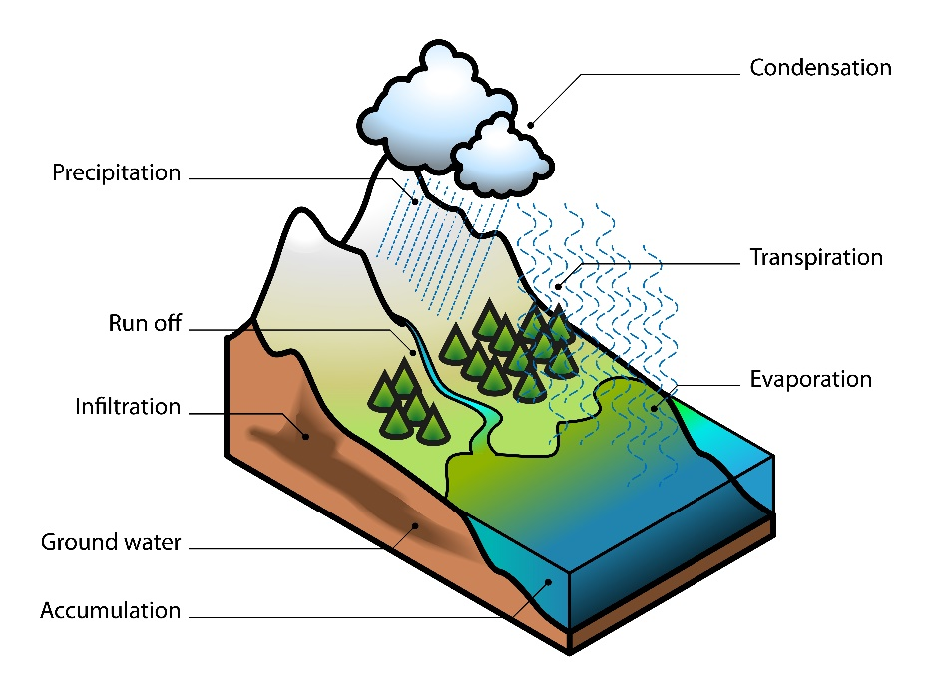
Activities on the landscape can introduce sediments and pollutants, affecting the usability of water for drinking and harming wildlife. Activities that disrupt the natural flow of water systems, such as dams and diversions, can alter natural processes and cause habitat loss.
The most significant concern facing northern lakes is overuse and development. Over the past 30 years, two-thirds of all lakes ten acres and larger were developed in northern Wisconsin. Continuing pressures are being placed on water resources and the number of people using these resources continues to grow annually.

Recently, changes have occurred in the way we view water resources. The Wisconsin Department of Natural Resources has taken a watershed approach to planning, because it focuses stakeholders on what a particular lake, river, or wetland needs and what they can do collectively to meet that need.

Watersheds
By definition, a watershed is an interconnected area of land draining from surrounding ridge tops to a common point such as a lake or stream confluence with a neighboring watershed.

The Town of Sherman lies entirely within Mississippi River Drainage Basin (Upper Chippewa Water Management Unit – Figure 5.5). Surface water drainage is accommodated via five major watersheds (Figure 5.6), including:

Upper North Fork Flambeau River

Upper South Fork Flambeau River

Flambeau Flowage
- Bear River

- Manitowish River

These major watersheds are composed of numerous sub-watersheds, or drainage areas for individual lakes and streams. Land use planning is best conducted at the sub-watershed scale, where it is recognized that stream quality is interconnected to local land use and impervious surface cover.
Figure 5.2: Iron County Basins Figure 5.3: Iron County Watersheds
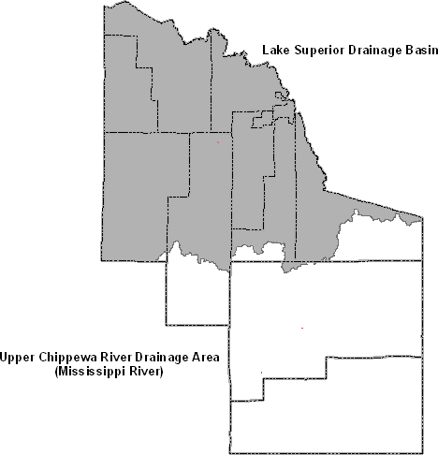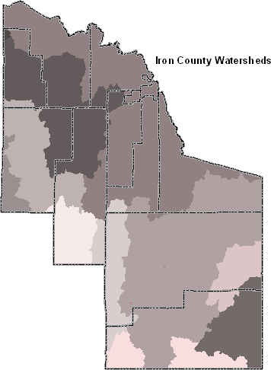

General Quality of Surface Waters
The quality of surface waters in the Town of Sherman is considered exceptionally good to excellent.

Impaired Water Bodies
Section 303(d) of the federal Clean Water Act requires the State of Wisconsin to periodically prepare a list of all surface waters in the state for which beneficial uses of the water – such as for drinking, recreation, aquatic habitat, and industrial use – are impaired by pollutants. These are water quality limited lakes, rivers, and streams that do not meet surface water quality standards and are not expected to improve within the next twenty years. Within the Town of Sherman, Bearskull Lake and the Turtle-Flambeau Flowage are classified as 303(d) waterbodies.

This impairment is the result of a high concentration of mercury, entering the lake through atmospheric deposition (dust, rain, snow). Mercury is a toxic metal released by both natural and manufactured processes. Although it does occur naturally, human activities have increased its concentration in the environment. Mercury can travel great distances in the atmosphere contaminating lakes far removed from the source. Because the impairment of these water bodies is primarily the result of atmospheric deposition, and the transport of air toxic substances is transboundary in nature, the State of Wisconsin will not establish Total Maximum Daily Loads (TMDLs) for these resources. A TMDL is a plan to reduce the number of specific pollutants reaching an impaired lake or stream.

The Wisconsin Department of Natural Resources has issued a fish consumption advisory (FCA) for both water bodies because of the elevated mercury levels.

ORW’s and ERW’s
Surface water resources have been evaluated and rated for water quality, fish, wildlife, and aesthetic values by the Wisconsin Department of Natural Resources. High quality resources were classified as either Outstanding Resource Waters (ORW’s), or Exceptional Resource Waters (ERW’s). An ORW is defined as a lake or stream having excellent water quality, high recreational and aesthetic value, high quality fishing, and is free from point source or nonpoint source pollution. An ERW is defined as a stream exhibiting the same high quality resource values as an ORW but may be impacted by point or nonpoint sources of pollution or has the potential for receiving a wastewater discharge from a non-sewered community in the future.

Town of Sherman ORW’s
North Fork Flambeau River
Turtle-Flambeau Flowage
Flambeau River

Town of Sherman ERW’s
Manitowish River

Lakes
Lakes are vital components of the community natural resource base. These resources provide unique habitats for wildlife, including a number of threatened and endangered species and communities. Lakes are also important recreational, social, and economic resources that characterize northern Wisconsin. Like across much of the state, lakes in Iron County are under ever increasing development pressure.

Iron County has 214 named lakes comprising 28,586 acres. There also exist 280 unnamed lakes in the county, occupying an additional 418 acres. The Town of Sherman has 3,000 acres of surface water (excluding the Turtle-Flambeau Flowage) in 55 lakes. Excluding the Flowage, the Town has 79 miles of shoreline. The largest water body in the Town is the Turtle-Flambeau Flowage, a manufactured reservoir created in 1926 by the damming of the Turtle and Flambeau Rivers. The Flowage is the largest publicly owned water resource in the State of Wisconsin. See Table 5.2 for more details.

Table 5.3: Lake Characteristics (Named Lakes)

Name | T | R | S | Acres | Max Depth | Miles Shoreline* | S.D.F.‡ | Lake Type†
Bass | 41 | 4 | 29 | 15.6 | 20 | 0.7 | 1.27 | S
Bearskull | 41 | 3 | 25 | 77.1 | 27 | 2.5 | 2.03 | D
Big Pine | 41 | 3 | 36 | 632.4 | 22 | 4.5 | 1.28 | D
Birch | 41 | 4 | 11 | 63.2 | 12 | 1.5 | 1.35 | D
Black | 41 | 4 | 24 | 29.3 | 20 | 1.0 | 1.32 | SP
Boot | 41 | 3 | 8 | 177.2 | 16 | 3.9 | 2.09 | S
Cap Henry | 41 | 4 | 20 | 48.1 | 61 | 1.7 | 1.75 | S
Charnley | 41 | 3 | 20 | 71.3 | 30 | 1.8 | 1.52 | S
Cranberry | 41 | 4 | 34 | 63.8 | 8 | 1.8 | 1.61 | SP
Cub | 42 | 4 | 21 | 11.7 | 17 | 0.5 | 1.04 | S
Doud | 41 | 4 | 24 | 21.5 | 13 | 0.9 | 1.39 | SP
Duck | 41 | 4 | 31 | 13.4 | 15 | 0.9 | 1.76 | D
East Reimer | 41 | 4 | 6 | 5.5 | 5 | 1.0 | 3.01 | D
Emerson | 41 | 3 | 24 | 4.6 | 23 | 0.5 | 1.67 | D
Ess | 41 | 3 | 16 | 55.0 | 12 | 2.1 | 2.02 | S
Fat | 41 | 4 | 24 | 98.8 | 23 | 1.9 | 1.36 | S
Fawn | 41 | 3 | 5 | 20.0 | 16 | 1.0 | 1.59 | S
Ferry | 41 | 3 | 23 | 72.5 | 48 | 2.2 | 1.84 | S
Flambeau Flowage | 42 | 2 | 34 | 13545.0 | 50 | 211.0 | 12.94 | D
French | 41 | 3 | 17 | 91.9 | 16 | 3.1 | 2.30 | S
Goose | 41 | 3 | 14 | 11.3 | 3 | 0.6 | 1.29 | S

Table 5.3: Lake Characteristics (Named Lakes)

Name | T | R | S | Acres | Max Depth | Miles Shoreline* | S.D.F.‡ | Lake Type†
Grant | 42 | 3 | 14 | 107.0 | 10 | 2.9 | 2.00 | D
Grey | 41 | 4 | 24 | 34.5 | 61 | 1.5 | 1.82 | S
Hourglass | 41 | 3 | 24 | 4.5 | 18 | 0.5 | 1.68 | S
Island | 41 | 2 | 13 | 56.0 | 5 | 1.8 | 1.72 | SP
Leach | 41 | 3 | 12 | 4.4 | 12 | 0.5 | 1.70 | S
Lehto | 41 | 4 | 19 | 53.2 | 10 | 1.7 | 1.66 | SP
Little Bear | 42 | 4 | 22 | 3.7 | 5 | 0.4 | 1.49 | D
Little Cap Henry | 41 | 4 | 20 | 20.1 | 21 | 0.9 | 1.43 | S
Little  Muskie | 41 | 3 | 29 | 47.2 | 32 | 1.5 | 1.56 | S
Lost | 41 | 4 | 36 | 5.0 | 11 | 0.4 | 1.28 | S
Lower Springstead | 41 | 3 | 28 | 95.1 | 25 | 2.4 | 1.76 | D
Marty | 41 | 3 | 32 | 13.2 | 30 | 0.8 | 1.57 | D
McDermott | 41 | 3 | 30 | 83.7 | 21 | 2.4 | 1.87 | D
Minette | 41 | 4 | 35 | 90.0 | 50 | - | - | -
Mirror | 41 | 4 | 7 | 57.5 | 7 | 2.0 | 1.88 | S
Mud | 42 | 4 | 23 | 55.7 | 7 | 1.4 | 1.34 | SP
Munnomin | 41 | 4 | 26 | 21.2 | 1 | 0.9 | 1.39 | SP
Muskie | 41 | 3 | 22 | 80.6 | 20 | 1.8 | 1.43 | D
Mystery | 41 | 3 | 19 | 13.2 | 43 | 0.7 | 1.38 | S
Negani | 41 | 4 | 27 | 17.7 | 30 | 0.9 | 1.53 | S
Norma | 41 | 3 | 19 | 6.9 | 15 | 0.5 | 1.40 | S
North Sister | 41 | 3 | 7 | 9.7 | 30 | 0.9 | 2.06 | S
Otter | 41 | 2 | 13 | 7.4 | 9 | 1.0 | 2.63 | D
Randall Lake | 41 | 3 | 17 | 114.7 | 10 | 2.3 | 1.53 | D
Reservation Line | 41 | 4 | 34 | 47.3 | 12 | 1.3 | 1.35 | S
Rice | 41 | 3 | 26 | 15.3 | 3 | 0.9 | 1.64 | D
Roberts Springs | 42 | 4 | 25 | 27.1 | 7 | 1.2 | 1.64 | SP
Sandy  Beach | 42 | 4 | 22 | 111.7 | 7 | 2.2 | 1.49 | D
Sherman | 42 | 3 | 4 | 123.0 | 19 | - | - | -
South Sister | 41 | 3 | 7 | 6.1 | 10 | 0.5 | 1.45 | S
Stone | 41 | 3 | 21 | 82.0 | 20 | 1.7 | 1.34 | D
Teal | 41 | 3 | 15 | 24.5 | 13 | 1.1 | 1.59 | S

Table 5.3: Lake Characteristics (Named Lakes)

Name | T | R | S | Acres | Max Depth | Miles Shoreline* | S.D.F.‡ | Lake Type†
Town Line | 41 | 3 | 35 | 9.0 | 17 | - | - | -
Thomas | 41 | 4 | 22 | 14.5 | 5 | 0.7 | 1.31 | S
Upper Springstead | 41 | 3 | 21 | 126.2 | 23 | 2.8 | 1.78 | D
West  Randall | 41 | 4 | 18 | 9.3 | 10 | 0.7 | 1.64 | D
West Reimer | 41 | 3 | 11 | 11.9 | 14 | 0.7 | 1.45 | S
Source: Iron County Lakes Classification
- ♦ Multiple sections
- *These figures represent acres, miles of shoreline and miles of public shoreline of entire water body, which may cross jurisdictional boundaries.
- †Lake Types: D=Drainage, SP= Spring, S= Seepage
- ‡The shoreline Development Factor (S.D.F.) is a method of expressing the degree of irregularity of shoreline compared to surface area. A S.D.F of 1.00 indicates a perfectly round circle; lakes cannot have a S.D.F. of less than 1.00. Lakes with higher S.D.F. have more shoreline in relation to surface area thus are more vulnerable to development pressures per linear foot of shoreline that is developed.
- Lake information in above table that are shown in Italic's are inside the Lac Du Flambeau Tribal Reservation
- Several unnamed lakes in the Town are not included in above table

Lake Sensitivity
The quality of lake water is highly dependent upon the type of activities that occur within its drainage area. People far from the resource can influence the water quality because of their activities on the land. The overall size of the watershed determines how much surface runoff will enter the lake basin. This, in turn, will determine the extent to which sediment and nutrients will impact the lake. As a rule, a lake with a large watershed area relative to lake area is most sensitive.

The lakes’ natural ability to flush and circulate water is also a function of watershed size. Nutrient loading rates tend to be lower in lakes with smaller watersheds, however, longer retention times (flushing rates) common to these lakes may also lead to more nutrient accumulation. The longest retention times occur on seepage lakes with no surface outlets.

10 Largest Lake Watersheds in the Town of Sherman

Lake Watershed (sq/mi)
Unnamed 25-5 1.1
Upper Springstead 1.3
Lower Springstead 1.8
Rice 2.3
West Randall 2.5
Bearskull 2.6
Randall 4.2
Grant 4.5
Big Pine 6.5
Flambeau Flowage 647

Requirements
Under the Public Trust Doctrine, the State of Wisconsin has the responsibility to manage waterways for the benefit of all and the Wisconsin Department of Natural Resources regulates activities on navigable waterways within the state. Chapter NR 115 of the Wisconsin Administrative Code requires all counties to zone, by ordinance, all shorelands within their respective unincorporated areas. These areas include all lands within 1,000 feet of a lake (including ponds and flowages) and within 300 feet of a navigable stream or landward extent of the floodplain (whichever is greater). Shorelands in Iron County are regulated under Title 13 - Shoreland Zoning Ordinance, which meets the minimum state standards outlined in NR 115.

Rivers and Streams
Like lakes, river and stream resources support a wide range of species and habitats, including many threatened and endangered species and communities. These resources are important natural sediment transport systems that move runoff and materials downstream. Activities on the landscape directly impact the quality and quantity of water in rivers and streams and the water bodies to which they flow.

The Town of Sherman has 78 miles of perennial streams. There are also many unnamed intermittent streams found in the Town. Perennial streams flow 365 days a year in a normal year. Intermittent streams have short or lengthy periods of time when there is no flow in a normal year. Intermittent streams are significant to the overall drainage regime, especially following major precipitation events and spring snowmelt. Perennial streams found in the Town of Sherman include:

- Bear River
- Beaver Creek
- Cedar Creek
- East Fork Hay Creek
- Flambeau River
- Hay Creek
- Island Creek
- Little Bear Creek
- Lost Creek
- Manitowish River
- Otter Creek
- Pine Creek
- Randall Creek
- Reimer Creek
- Rice Lake Creek

Requirements
Under NR 115, Wisconsin counties are required to zone, by ordinance, all shorelands within their respective unincorporated areas. This includes all lands within 300 feet of a navigable stream or landward extent of the floodplain (whichever is greater). Rivers and streams in Iron County are regulated under Title 13 - Shoreland Zoning Ordinance.

Table 5.4: Iron County Rivers and Streams Development Standards

Class | Lot Size | Single-Family Dwelling Average Lot Width | Shoreline Setback | Vegetation Removal
Rivers and Streams | 10,000 ft²  20,000 ft^{2(a)} | 65ft  100ft^{(a)} | 75ft | 35 ft corridor per 100 feet of shoreline
Source: Iron County Shoreland Ordinance
^{(a)} = Standards for unsewered dwelling units

Groundwater
Groundwater is fresh water from rain or melting ice and snow that soaks into the soil and is stored in the tiny pores between rocks and particles of soil. Groundwater is the primary source of all household water in the Town of Sherman.

Groundwater Quantity
Ample supplies of groundwater are found under most of Iron County. Under natural conditions, a balance existed between the volume of water entering an aquifer and the volume of water being discharged from an aquifer. With the development of water wells, the natural balance between recharge rates and discharge rates was disrupted. In Wisconsin, the overall groundwater supply has been depleted due to increased discharge. Natural fluctuations in groundwater supply can occur due to droughts or natural seasonal precipitation fluctuations.

* The Upper Chippewa basin in a WDNR Water Management Unit (WMU), a hydrologically based subdivision of the larger Major Basin. The Upper Chippewa is a subdivision of the Mississippi River Basin.

Groundwater Quality
The quality of natural groundwater varies by location. As groundwater passes through natural sediments, naturally occurring chemicals may become deposited in the water. While naturally occurring groundwater contamination is mild, human-induced contaminants can make groundwater supplies unusable. The quality of groundwater is related to land use activities. The application of fertilizers, chemical spills, urban runoff, and non-point pollution can contribute to decreased quality of groundwater reserves. The chemical composition of groundwater throughout the county is exceptionally good; although, instances of localized problems such as mineralization, hardness, and high iron content do occur. At this time, pollution from human activities is not a significant problem in the Town of Sherman but continued diligence is necessary.

Figure 5.6: Depth to Water Table
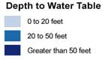
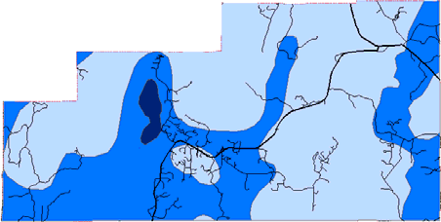

Figure 5.7: Groundwater Contamination Susceptibility
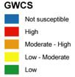

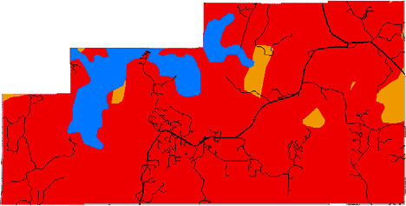

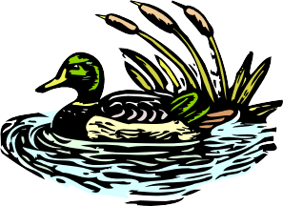
Wetlands
In 1978, the Wisconsin State Legislature officially defined wetlands as “an area where water is at, near, or above the land surface long enough to be capable of supporting aquatic or hydrophytic (water-loving) vegetation and which has soils indicative of wet conditions”.

Wetland environments sustain a diverse range of plants and animals, including several threatened, endangered, and sensitive species. These areas are significant habitat resources for migratory waterfowl and are primary nesting and breeding areas for species such as mallard, black duck, wood duck, blue-winged teal, and green-winged teal. Wetlands are also habitat for furbearing mammals such as beaver, muskrat, mink, and otter. Wetlands provide a variety of important ecological “services,” such as water quality improvement through sediment and contaminant removal. Wetlands also absorb and store excess water by releasing water more slowly than gained , reducing costly flood damage from storms, snowmelt, and runoff. Wetlands also stabilize shorelines and reduce erosion by reducing the impact of wave action.

The Wisconsin Department of Natural Resources categorizes wetlands into five prominent types: aquatic bed, marshes, sedge or wet meadows, scrub/shrub, and forested wetlands.

- Aquatic Bed Plants growing entirely on or in a water body no deeper than six inches. Plants may include pondweed, duckweed, lotus, and water lilies.

- Marshes Characterized by standing water and dominated by cattails, bulrushes, pickerelweed, lake sedges, and/or giant bur-reed.

- Sedge or "Wet" Meadows These wetlands may often have saturated soils rather than standing water. Sedges, grasses, and reeds are dominant but may also contain blue flag iris, marsh milkweed, sneezeweed, mint, and several species of goldenrod and aster.

- Scrub/Shrub Bogs and alder thickets are characterized by woody shrubs and small trees such as tag alder, bog birch, willow, and dogwood.

- Forested Bogs and forested floodplain complexes are characterized by trees 20 feet or more in height such as tamarack, white cedar, black spruce, elm, black ash, green ash, and silver maple.

The Wisconsin Wetland Inventory (WWI) was completed in 1985. The inventory identified all wetland areas in Iron County larger than two acres. The WWI indicates that 31.8 percent of Iron County is classified as a wetland, the third largest percentage of any Wisconsin County. Please refer to Map 5.9, Wetlands for WWI wetlands in the Town of Sherman.

Table 5.5: Town of Sherman, Wetland Inventory
Class | Acres
Emergent/wet meadow | 886.5
Forested | 19,917.8
River | 33.3
Scrub/shrub | 13,430.7
Grand Total | 34,268.2
Source: WI Wetland Inventory

Wetlands account for more than 34,000 acres, or 40 percent of the total acreage of the Town of Sherman (Wisconsin Wetlands Inventory –WDNR). The three dominant wetland types found locally are emergent/wet meadow, aquatic bed, scrub/shrub, and forested wetlands. Wetland ecosystems are sensitive natural resources, which provide vital environmental functions such as water purification, flood control, and groundwater recharge, as well as providing habitat for numerous plant and animal species.

Requirements
The use and development of wetlands in Wisconsin is regulated under local, state, and federal requirements.

Iron County
Wetlands in Iron County are regulated under the Iron County Shoreland Zoning Ordinance (W-2 Shoreland-Wetland District). This district is comprised of shorelands that were designated as wetlands (five acres and greater) on the Wisconsin Wetland Inventory maps adopted by Iron County.

State of Wisconsin
NR115 and 117: Shoreland and wetland zoning regulations provide minimum wetland protection requirements for lands within 1,000 feet of the ordinary high-water mark of waterways and requires local units of government to adopt and enforce local zoning ordinances.

NR30 and 31: Navigable waters protection requirements regulate construction and waterway alteration in and adjacent to navigable waters, including dams, filling, water diversion, grading, and dredging.

NR103 and 299: Water quality certification standards which the Wisconsin Department of Natural Resources uses to approve or deny permits after the Army Corps of Engineers approves them.

Wisconsin Act 6: Isolated Wetland Protection Law authorizes the WDNR to administer the water quality certification program for projects in those isolated wetlands that are currently not protected under the Clean Water Act.

Federal
Section 404 of the Clean Water Act regulates discharges to "waters of the U.S." including fill in any wetland.

Section 10 of the Rivers and Harbors Act of 1899 regulates activities in navigable waters of the U.S.

Floodplains
Areas that are subject to periodic inundation by water are considered floodplains. The physical floodplain boundaries were determined by the Federal Emergency Management Agency (FEMA) and are portrayed in the National Flood Insurance Program (NFIP) maps.

Physical development within designated floodways is strongly discouraged. However, some uses within this zone are appropriate. Agricultural practices, parks, and open space are appropriate uses within these areas. Within the flood fringe (exterior limits of the floodplain) more intensive uses are permitted.

FEMA has determined areas of flood susceptibility in the Town of Sherman. The Flood Hazard Boundary Map (FHBM) series for Iron County depicts these flood zones as shaded areas, referred to as the Special Flood Hazard Area (Zone A). Areas labeled as Zone A are subject to inundation by a 100-year flood. Because detailed hydraulic analyses have not been performed, no base flood elevation or depths are depicted. Federal Law mandates that federally connected lending institutions require flood insurance on loans involving buildings on property located partially or within these areas.

Floodplains in the Town of Sherman are mapped on series numbers 550182 0008A, 550182 0009A, and 550182 0010A. Flood hazard areas are defined along several lakes and the main channels of many rivers and streams. The area within the Lac du Flambeau Indian Reservation has not been mapped by FEMA. Copies of Floodplain maps are available for review at the Iron County Zoning Office.

Rivers and Streams with Mapped Floodplains

- Bear Creek, to Sugarbush Creek
- Beaver Creek
- Flambeau River
- Hay Creek,
- Hay Lake to Hay Creek
- Flowage Island Creek
- Lost Creek
- Little Lost Creek
- Manitowish
- River Otter Creek
- Randall Creek
- Rice Lake Creek
- Springstead Creek
- Sugarbush Creek
- Thompson Creek
- Tributary to Flambeau River, Section 7 T41N-R2E

- Unnamed, Rice Lake to Bearksull Lake
- Unnamed , Section 29, T41N-R4E to Duck Lake
- Unnamed, Section 32, T41N-R4E to Duck Lake

Lakes with Mapped Floodplains

- Bearskull Lake
- Big Pine Lake
- Duck Lake
- Ess Lake
- Grant Lake
- Hay Lake
- Lake Nine
- Lehto Lake
- Little Muskie Lake
- Lower Springstead Lake
- Mud Lake
- Muskie Lake
- Otter Lake
- Randall Lake
- Rice Lake
- Stone Lake
- Teal Lake
- Turtle-Flambeau Flowage
- Upper Springstead Lake
- West Randall Lake
Section 87.30 of the Wisconsin State Statutes and Chapter NR 116 of the Wisconsin Administrative Code define the state’s regulations with respect to floodplains. Iron County adopted floodplain zoning maps (FIRM Flood Insurance maps), prepared by the U.S. Department of Housing and Urban Development dated April 1, 1988. Zoning Ordinance regulates uses within county floodplains. Determination as to whether a building site is in a floodplain must be made through zoning office review of floodplain maps or through field verification of flood boundary.

Threatened, Endangered and Sensitive Species and Communities
Ospreys inhabit portions of the Turtle-Flambeau Flowage along with the largest concentration of bald eagles in the State of Wisconsin. Occasional moose sightings are reported near the Turtle-Flambeau Flowage. Gray wolves, a threatened species in Wisconsin, may also be present in the Town. Lands within the Town, particularly within the TFSWA, contain suitable habitat for many species of threatened or endangered wildlife not currently known to exist in this area.

Wisconsin’s Natural Heritage Inventory Program (NHI) focuses on locating and documenting occurrences of rare species and natural communities, including state and federal endangered and threatened species. NHI data is exempt from the Wisconsin Open Records Law due to the vulnerable nature of these sensitive resources. Determination of the specific locations of sensitive resources within the Town of Sherman will require coordination between the Town and the Wisconsin Department of Natural Resources.

Wildlife Resources

Wildlife and wildlife habitat are fundamental components of natural ecosystems. The health and relative abundance of these resources is intimately linked to all other facets of community development. As part of the planning process, it is important for the community to recognize the significance of these resources and strive to protect and enhance them.

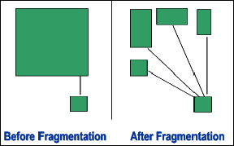
There are three primary issues of concern related to wildlife habitat planning: fragmentation, invasive/exotic species, and pollution. Fragmentation is the breaking up of large contiguous tracts of habitat into smaller pieces. This process increases the amount of linear edge areas, creating more “edge habitat” that favor species such as whitetail deer and ruffed grouse. An increased amount of edge habitat is accompanied by a variety of negative impacts including increased predation/competition among species and increased range expansion of exotic species. Heavy browsing from and expanding population of whitetail deer can alter the types of plant species that grow in some areas. As a result, some desirable or rare plant species may become threatened. Deer are thriving in many parts of Wisconsin because humans have created substantial amounts of edge habitat. Core species such as wolves and interior songbirds can be negatively impacted by the loss of interior habitat.

Invasive/exotic species pose serious threats to wildlife populations. These species, once established, can decimate native species by out competing them for food and/or habitat. Because exotics are not part of the native ecosystem, they often have no natural (local) predators, thus may become prolific once established.

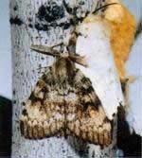
An exotic species of concern for Iron County is the Spongy Moth, which has been steadily progressing westward since it’s introduction to the United States in 1869. Iron County is one part of the two thirds of Wisconsin under Spongy Moth quarantine. Other exotics of concern in Iron County include the zebra mussel (mussel), purple loosestrife (aquatic plant), curly leaf pondweed (aquatic plant), garlic mustard (plant), rusty crayfish (crustacean), everlasting pea (plant), eurasian water milfoil (aquatic plant), and the emerald ash borer (insect).

Photo: University of Illinois-Extension

Pollution is also a major concern for wildlife populations. The introduction of contaminants such as mercury, sulfur dioxide (associated with acid rain), and ozone can have local, regional, and even global impacts.

Contaminants in the environment may also cause reproductive harm to wildlife species and may even cause direct mortality. Environmental contaminants can also travel to the local community from sources located outside of the area via rain, dust, and wind.
Wildlife habitat is abundant in the Town of Sherman. The relative abundance of forests, lakes, rivers, and wetlands provides opportunities for many species to thrive. The large public land base provides exceptional habitat opportunities due to,
- Low road density
- Low population density
- Large core areas/ less habitat fragmentation
- Natural connectivity, connected biological reserves
- Managed for wildlife

The Turtle-Flambeau Scenic Waters Area is a 19,000-acre tract of state-owned lands located in the Towns of Mercer and Sherman. This resource provides a rich diversity of wildlife habitat and is a crucial resource for migratory birds and waterfowl. The rich upland vegetation and wetland communities provide for the needs of many species of birds and mammals, including many threatened and endangered species.

The Hay Creek Hoffman Lake State Wildlife Area, a 13,424-acre wildlife preserve, provides habitat for species such as ruffed grouse, deer, woodcock, bears, loons, waterfowl, beavers, otters, fishers, coyotes, bobcat, muskrats, ospreys, eagles, and timber wolves. This area is popular for bird watching.

A patterned peatland bog is in the Boot Lake Wildlife Area. This bog community is extremely rare in Wisconsin but is common in northern Minnesota and Ontario, Canada. Wetland ecosystems are sensitive natural resources, which provide vital environmental functions such as water purification, flood control, groundwater recharge, as well as providing habitat for numerous plant and animal species.

The Northern Highland-American Legion (NAHL) State Forest, which comprises a portion of the Town of Sherman, is the largest state-owned property at over 220,000 acres. Within the state forest area, the Northern Highland State Forest was created in 1925 and the American Legion State Forest was created in 1929. It was not until 1968 that the two state forests were combined into one management unit. Within the NHAL, there are a total of 902 lakes of which 26 are in Iron County.

Protecting habitat is critical to species preservation. The preservation of habitat not only benefits wildlife, but also provides benefits to humans, including: the preservation of open space, recreational opportunities, aesthetic benefits, and improved air/water quality.

Planning Principles for Habitat Protection

  - Maintain large, intact patches of native vegetation by preventing fragmentation of those patches by development.
  - Establish priorities for species protection and protect habitats that promote the distribution and abundance of those species.
  - Protect rare landscape elements. Guide development toward areas with more common landscape elements.
  - Maintain connections among wildlife habitats by identifying and protecting corridors for movement.
  - Maintain significant ecological processes such as fires and floods in protected areas.
  - Contribute to the regional persistence of rare species by protecting some of their habitat locally.
  - Balance the opportunity for public recreation with the habitat needs of wildlife.

Metallic and Nonmetallic Minerals and Mining
Iron County has a rich mining heritage. The Penokee-Gogebic Range in north-central Iron County was a major source of iron from the 1880’s through the 1960’s. Evidence of the county’s mining history can be seen in the several abandoned prospects and past producing mines located throughout the highlands of the range. According to the US Geological Survey Mineral Resources Data System database, there are no existing or former metallic mining sites in the Town of Sherman.

Regulations
A metallic mine in Wisconsin is subject to many rules and regulations. Before a mine can be developed, Wisconsin requires a metallic mining permit and approved plans for environmental monitoring, mining, and reclamation, a risk assessment, and a contingency plan. An Environmental Impact Statement (EIS) must be prepared by the WDNR to assess the potential impacts of the proposed mine. The WDNR is also responsible for monitoring construction, mining, and reclamation activities.

The Wisconsin mining statutes state that the local municipality within which a metallic mine site is located has zoning approval authority over a proposed metallic mine. Before a proposed metallic mine can receive approval from the state, the local municipality must have granted its approval under its zoning or land use ordinances or have entered into a legally binding agreement with the mining proponent.

Nonmetallic Mineral Resources

Per Iron County Zoning records, there are 3 permitted nonmetallic mining sites (sand and gravel) in the Town of Sherman. Two of them are private and the third is Town owned.

Regulations
Chapter NR135 of the Wisconsin Administrative Code requires that all counties develop and adopt a nonmetallic mining reclamation ordinance. NR 135 ensures that all nonmetallic mining sites are reclaimed in compliance with the uniform statewide reclamation standards by providing the detailed requirements and reclamation standards for local ordinances. The Iron County Ordinance for Nonmetallic Mining Reclamation was approved March 29, 2016. Article F, Section 9-1-101 of the Iron County Zoning Ordinance also regulates quarries and mines as special uses.

Land Management
Land ownership influences development patterns and land use, management, policy, and public use/access. Public lands are important economic and social resources for local communities. These lands generate revenue for local units of government through the harvest and sale of timber. They also support recreation and tourism activities such as hunting, fishing, snowmobiling, ATVs, and fall color tours, which also generate local revenue.

Publicly Managed Lands
Forest Crop Law
Program Highlights
- Law passed in 1927, enrollment closed in 1986
- Current statewide enrollment of 1.4 million acres
- Required at least 40 acres of adjoining forest land
- Public access
- Management schedule

Managed Forest Law
Program Highlights
- Enacted in 1985
- 25 or 50-year contract period
- Requires at least 20 acres of contiguous forestland
- Productive capacity requirements
- Landowner payments $2.04 cents/acre for open land and $10.20/acre for closed land.
- Cutting and reporting requirements

Program Benefits
- management plan
- protection against overcutting
- protection against annual tax hike
- low property tax
- deferred tax until harvest
- landowners' right to close up to 80 acres of their lands to the public
- technical assistance
- permits rollover from FCL through January 1, 1998
- predictable taxes
- long-term investment
- encourages woodland expansion
- minimum land area requirement of only 20 acres

Overall Land Base 87,845 ac
State Lands 32,694 ac
FCL/MFL Lands 8,862ac

Other Managed Lands

Lac du Flambeau I.R. 14,532 acres

Managed lands are depicted in Map 8.4, Land Management, Town of Sherman.

Lac du Flambeau Band of Chippewa Indians
The Lac du Flambeau Indian Reservation occupies 86,630 acres in Iron, Vilas, and Oneida Counties of northern Wisconsin. Of this total, 14,533 acres lie within the Town of Sherman. See Figure 5.9 below. The Treaty of 1854 defined the Reservation and established the formal boundaries. The Lac du Flambeau tribe has 2,400 enrolled members, governed by a 12 member Tribal Council.

The Reservation is situated in an area rich in water, forest, and other natural resources. These resources are important to the people of the Lac du Flambeau for cultural, spiritual, and subsistence purposes. Natural resource management is the primary responsibility of the Tribal Natural Resources Department (TNR), an agency, which provides the workforce, materials, supplies equipment and facilities necessary to manage the reservation's natural and cultural resources.

Figure 5.8: Lac du Flambeau Reservation Boundaries
Lac du Flambeau Indian Reservation
Iron County
Vilas County
Town of Sherman
Price County
Oneida County

  - AGRICULTURAL RESOURCES

Agricultural land comprises a small proportion of the overall land base in the Town of Sherman. According to land cover estimates, about .15 percent of the 117.9 square mile land base is actively used for either row crops or grassland.

The 2020 Statement of Assessments (Wisconsin Department of Revenue) states that 59 acres were assessed agricultural.

The Iron County Zoning Map shows a substantial number of parcels zoned as Agricultural (6,046.3 acres). As of 2021, there is only one 32-acre parcel in the Town of Sherman being used as Agricultural land. The remaining parcels zoned Agriculture are not being used as such.

Agricultural suitability within the Town of Sherman is limited due to soil, environmental and economic conditions, including

    - Large public land base
    - Poor soil conditions
    - Short growing season
    - Proximity to markets

The 2017 Iron County Farmland Preservation Plan identified NO areas within the town of Sherman as farmland preservation areas.

  - CULTURAL AND HISTORIC RESOURCES

Cultural and historic sites and features are important community resources. These resources provide a critical link between the present and the past. The Town of Sherman values its cultural and historic resources and is committed to work to retain their intrinsic value for future generations to enjoy.

The official historic resource catalog for the State of Wisconsin is the Wisconsin Architecture and Heritage Inventory (AHI). The AHI is a search engine that contains a documentation of 120,000 properties in the State of Wisconsin. The Wisconsin Historical Society, based in Madison, Wisconsin, maintains this database.
It is important to note that the AHI is not a comprehensive listing of Wisconsin’s historic resources. It is likely that other historic properties and resources exist within the Town of Sherman but have yet to be identified or published.

National Register of Historic Places

The National Register of Historic Places is the Nation’s official list of cultural and historic resources worthy of preservation.

Archaeological Sites and Cemeteries
Our lives are influenced by what we learn from our own experiences and by the events that have shaped the communities we live in and the institutions and organizations we encounter. Our history gives us a sense of place and a framework to understand the world. It provides continuity and meaning in our lives, and it can be a basis for economic development through preservation programs and heritage tourism.

People have been living in the area for as long as anyone can remember, with hunting, fishing, farming, and forestry playing a leading role in people’s lives. This story of agriculture, resource use, and land stewardship is preserved in archaeological sites, buildings, landscapes, written accounts, photographs, governmental records, and the thoughts and ideas people remember and pass along by word of mouth. Planning can play a critical part in protecting these resources and in learning from this wealth of experience. Land use planning and land use decisions will directly impact historic buildings, archaeological sites, and cemeteries.

Archaeological sites include places where people lived, where they worked, and where they worshiped. These sites were made by the people who lived at the village, farm, or logging camp located just down the road. Archaeological sites occur figuratively and under our feet. Archaeology is well suited for providing valuable information about the lives of people who are not well represented in the written record. Archaeological sites are nonrenewable resources and once a site is destroyed, either by natural or human related activities, it cannot be reclaimed.

The Wisconsin Historical Society (WHS) maintains a list of archaeological sites and cemeteries referred to as the Archaeological Site Inventory (ASI) a component of the Wisconsin Archaeological and Historic Resource Database (WisAHRD). The Archaeological Site Inventory (ASI) is the most comprehensive list of archaeological sites, mounds, unmarked cemeteries, marked cemeteries, and cultural sites available. The ASI does not include all the sites and cemeteries present in the state, however. It includes ONLY those sites that have been reported to the Wisconsin Historical Society. The information in the ASI is a compilation of reports covering a period of 150 years. The information for each entry varies widely and WHS has not been able to verify all the entries. Few of these sites have been evaluated for their importance. The ASI is changed and updated daily and recommendations about site importance may change, as added information becomes available.

This ASI information is confidential and is not subject to Wisconsin’s open records law (Wis. Stats. §§ 44.48 and 157.70). This information is also protected by Federal law (Section 304 of the National Historic Preservation Act, Section 9(a) of the Archaeological Resources Protection Act of 1979). This caution not only helps protect archaeological sites but also protects landowners since private landowners own most archaeological sites in the Town.

Under Wisconsin law, Native American burial mounds, unmarked burials, and all marked and unmarked cemeteries are protected from intentional disturbance. If you have any questions concerning the law, please contact the Coordinator of the Burial Sites Preservation Program at the Wisconsin Historical Society.

Archaeological Sites and Cemeteries in the Town of Sherman

The Wisconsin Historical Society maintains a list of archaeological sites and cemeteries referred to as the Archaeological Site Inventory (ASI).

Since only a small portion of the Town has been surveyed for the presence of archaeological sites and cemeteries, the sites listed in the inventory represent only a fraction of the sites that are present. Residents and Indigenous communities who have and do live and work in the area possess much additional information on other archaeological sites and cemeteries. Steps should be taken to have this information incorporated into the land use plan.

Up to this point in time, one archaeological site has been reported for the Town. This site is at the Springstead Historic District and has the following types of buildings:

- Sugar bush
- Cabin/homestead

Clearly this sample of sites does not reflect the rich history of the area. Many more sites are present in the area. No sites are listed on the National and State Register of Historical Places, but many sites in the Town certainly may be eligible and important.
Where are archaeological sites going to be located? Using the results of archaeological surveys, relevant historical and environmental data, the following high priority areas were designated:

- higher, dryer areas adjacent to rivers, streams, creeks, lakes, wetlands
- higher, dryer areas adjacent to older abandoned rivers, streams, creeks, lakes, wetlands
- rock outcrops and upland ridges
- areas adjacent to older historic features such as trails, early roads, rail corridors, and earlier communities

Cemeteries, Burial Mounds, and Other Burials

Cemeteries and burial areas have been set aside as specific areas throughout Wisconsin history and they have been given special protection under the law.

Under Wisconsin law, Native American burial mounds, unmarked burials, and all marked and unmarked cemeteries are protected from intentional disturbance. If anyone suspects that a Native American burial mound or an unmarked or marked burial is present in an area, the Burial Sites Preservation Office should be notified. If human bone is unearthed during any phase of a project, all work must cease, and the Burial Sites Preservation Office must be contacted at 1- 800-342-7834 to be in compliance with Wis. Stat. 157.70 which provides for the protection of all human burial sites. Work cannot resume until the Burial Sites Preservation Office gives permission. If you have any questions concerning the law, please contact the Coordinator of the Burial Sites Preservation Program at the Wisconsin Historical Society.

At the present time, no cemeteries or burials have been identified in the Town. Since a systematic survey of the county has not been completed, cemeteries and burials may be present. As part of the planning process, all cemeteries and burials in the Town should be cataloged under Wis. Stat. 157.70 to provide for the maximum protection of these important sites and to clearly define their boundaries.

How do we know which archaeological sites need preservation? Under Wisconsin law Native American burial mounds, unmarked burials, and all marked and unmarked cemeteries are protected. In addition to these, a wide variety of archaeological sites may be worthy of preservation. Using the State and National Register of Historic Places, a procedure for identifying important sites is available. The criteria include: a good local example of an architectural style and period; association with a person important in our past; represent an important period, movement, or trend in local, state, or national history; or have the potential to yield valuable information about our past through archaeological investigations.

Protecting Important Archaeological Sites

The wide variety of methods used to protect natural resources can also be used to protect archaeological sites. For example, land purchases, easement purchases, zoning, and the state operates a tax exemption program for property owners.

With the 1991 changes to Wis. Stats. 70.11 [see 70.11(13m)] it became possible to provide a property tax exemption for owners of archaeological sites listed in the national or state register of historic places. To obtain the tax exemption, the landowner must agree to place a permanent protective covenant for the site area in the deed for the property. The tax exemption program makes the landowner and subsequent owners stewards of Wisconsin's past. The intent of the
program is not to discourage all use of the property containing a site, but to encourage land use planning that protects sites.

Under Wisconsin law, Native American burial mounds, unmarked burials, and all marked and unmarked cemeteries are protected from intentional disturbance.

How are archaeological sites and cemeteries identified and evaluated?

Archaeological identification and evaluations are required for a variety of projects that receive federal or state funding, licenses, or permits. These projects are automatically forwarded to the Wisconsin Historical Society for review. Residents frequently report sites and cemeteries.

Table 5.7: Archaeological sites and cemeteries in the Town of Sherman
State Site # /  Burial Code # | Site Name / Type | Cultural Study Unit | Town-Range-Section
IR-0037 | Springstead  - Sugar bush  - Cabin/homestead | - Historic Native American  - Historic Euro-  American | 41, 3, E, 21
Source: Wisconsin Historical Society

Resources for Historic Preservation
Iron County Historical Society; ironcountyhistory.org
Gogebic Range Genealogy Society; gogebicroots.com
The Wisconsin State Historical Society; wisconsinhistory.org

Books containing historical information about the Town of Sherman
Several books have been published that contain significant historical information about Springstead and the Town of Sherman. These books are as follows and may be sold out:
- Reflections of Powell and Springstead by Charlotte Holbrook Morrill
- Memories of Springstead by Norman Pripps
- Rooted in Resources – funded by Iron County, edited by Cathy Techtmann, UWEX
- 100 Years on The Flambeau 1889-1989
- An Accidental Jewel, Wisconsin’s Turtle-Flambeau Flowage by Michael Hittle
- Bringing Up the Old Times of Springstead by Fred and Arvella Losby

  - NATURAL, AGRICULTURAL AND CULTURAL RESOURCE PROTECTION PROGRAMS

The Town of Sherman in the implementation of this comprehensive plan may use the following list of programs. This list is not comprehensive; and many other local, state, and federal programs may also exist. It should be noted that many of the natural resource protection programs could also be applied to agricultural resources.

Natural Resource Agencies and Programs

Iron County Land and Water Conservation provides technical assistance, education & outreach, and financial assistance for a variety of soil and water issues. https://ironcountylwcd.com; 715-561-2234.

Wisconsin Lakes Partnership

Recognized as a national model of collaboration, we work cooperatively with to support our lakes:

Wisconsin Department of Natural Resources (WDNR) supplies technical expertise and regulatory authority; https://dnr.wisconsin.gov .

University Wisconsin-Extension (UWEX) provides educational materials and programs; https://www3.uwsp.edu/cnr-ap/UWEXLakes/Pages/default.aspx

Wisconsin Lakes serves as the voice for concerned citizens, communities and lake groups statewide; www.wisconsinlakes.org

Wisconsin Woodland Owners Association; wisconsinwoodlands.org

Northwoods Land Trust; northwoodslandtrust.org

Wisconsin Wetlands Association; wisconsinwetlands.org

Turtle-Flambeau Flowage & Trude Lake Property Owner’s Association; tfftl.org

Springstead Lake Property Owners

Programs and Grants

Lake Planning Grants – WDNR

Lake Protection Grants – WDNR

Wisconsin Forest Landowner Grant Program (WFLGP) – WDNR

Forestry Incentives Program (FIP) – Natural Resource Conservation Service (NRCS) and WDNR

Managed Forest Law (MFL) - WDNR

Steward Incentives Program (SIP) – WDNR and Farm Service Agency (FSA)

Runoff Management Programs – WDNR

Wildlife Habitat Incentives Program (WHIP) – NRCS and WDNR

Observation Reserve Program (CRP) – FSA, NRCS and WDNR

Environmental Quality Incentives Program (EQIP) – NRCS and WDNR

Conservation Easement – IRS

Agricultural Resource Programs

Wisconsin Department of Revenue Farmland Preservation Programs

Wisconsin Farmland Protection Program (FRPP)

Cultural and Historic Resource Protection Programs

Wisconsin Historic Preservation Fund

Wisconsin Humanities Council Historic Preservation Grants

National Trust for Historic Preservation/Jeffris Preservation Services Fund (PFS)

Wisconsin Coastal Management Gants Program

  - NATURAL, AGRICULTURAL, AND CULTURAL RESOURCES GOALS, OBJECTIVES, AND ACTIONS

Natural resources play an important role in the Town’s economy and each citizen plays a role in the management of our natural resources. Our collective actions will largely determine whether the Town’s land, water, groundwater and forest resources are improved or degraded. It is important to balance the needs for environmental protection and responsible stewardship with use of private property and economic development.

A set of goals, objectives and action steps has been developed to assist the Town of Sherman in natural and cultural resources. Implementation of the identified actions will assist in achieving the overall goal.

Natural Resources, Agriculture Resources and Cultural Resources
Goal 1: TO HAVE NATURAL AND AGRICULTURAL RESOURCES THAT ARE PROTECTED.
Objective 1: Work to protect lakes, rivers, wetlands, woodlands and forests .
Action 1: Align with Iron County Land and Water Conservation, the WDNR and other cooperating agencies to increase awareness and knowledge about best management practices:
- Clean Boats/Clean Water program
- Shoreland stabilization including native planting, buffer zones and riparian establishment
- Fish stocking regulations
- Fishing regulations
- Aquatic invasive species and terrestrial species identification and removal
- Responsible use of herbicides and phosphorus-free fertilizer
- Lake water quality testing
- Culvert sizing and placement

Action 2: Encourage forestry practices that utilize woodland buffers during harvest.
Objective 2: Protect groundwater and other sensitive natural areas.
Action 1: Encourage land owners to properly maintain private wells through regular inspection and water testing.

Action 2: Collaborate with Iron County Land and Water Conservation to encourage proper well abandonment.

Action 3: Discourage improper waste disposal and unauthorized burning.

Objective 3: Discourage development within environmentally sensitive areas.

Objective 4: Encourage residents to collaborate with Iron County Land and Water Conservation and Natural Resource Conservation Service (NRCS) to incorporate best management practices related to agriculture practices

GOAL 2. TO HAVE HISTORICAL AND CULTURAL RESOURCES ARE PRESERVED.
Objective 1: Support local preservation efforts to document and preserve materials and personal documentaries of personal interest.
Objective 2: Support local preservation efforts to educate and display historical photos/artifacts about the Town.
Objective 3: Promote the formation of the Sherman (Springstead) Historical Society.

